USER REQUIREMENTS

The Bidder should provide the following in the specified order in Section 4 of the proposal/bid document.

Provide detail information of the proposed solution as per document enclosed. Please note that marking should be carried out in the following manner; The Remarks column should be used to explain or provide detail information.

DESCRIPTION | REMARKS
Rating - 5 | If the User requirement is met 100% as defined in the RFP without any work around method.
Rating - 4 | If the User requirement is met 75% as defined in the RFP without any work around method. Define the number of hours required for the modification and cost in US$ in the Remarks column, in order to provide 100% functionality as defined.
Rating - 3 | If the User requirement is met 50% as defined in the RFP without any work around method. Define the number of hours required for the modification and cost in US$ in the Remarks column, in order to provide 100% functionality as defined.
Rating - 2 | If the User requirement is met 25% as defined in the RFP without any work around method. Define the number of hours required for the modification and cost in US$ in the Remarks column, in order to provide 100% functionality as defined.
Rating - 1 | If the User requirement is met as a Work around method defined in the RFP. Define the number of hours required for the modification and cost in US$ in the Remarks column, in order to provide 100% functionality as defined.
Rating - 0 | If the User requirement is not met as a defined in the RFP and modifications are required. Define the number of hours required for the modification and costs in US$ in the Remarks column.

The NBL rating is as follows:
1 = critical; 2 = essential; 3 = nice to have

CURRENT ACCOUNTS

Ref : | User requirements | NBL Priority | Bidder’s Rating | Bidder’s Remarks
 | Facility to maintain multiple current accounts for different products (overdraft/SIERRA) with different controls and features. The same products could be offered in DBU and FCBU. | 1 | 5 | Supported by T24. The system provides parameter tables to define different type of Account for different product category which 1 customer can have.  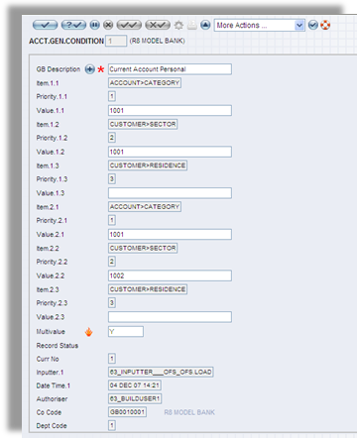  Figure 1. The ACCT.GEN.CONDITION screen
 | Current accounts could be in any currency in DBU and FCBU. | 1 | 5 | Supported by T24. Setting up of DBU and FCBU may require further discussion with NDB. It is suggested that FCBU be set up as a separate company during the POC with Peter Liew.
 | Facility to define cheque book facility per account irrespective of the currency.  Only to Rupee Accounts | 1 | 5 | Supported by T24. User can define format of cheque book.
 | Facility to retain the existing account number.  Ability to use the same account number with different currencies. (e.g. one current account number with different currencies) | 1 | 5 | Yes, supported. T24 is a multi-currency system.
 | Facility should also be provided to enter customer requested account number. | 1 | 5 | Supported by T24.  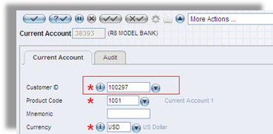  Figure 2 Current Account
 | Facility to open accounts under one customer name/number and account identity in both the units namely DBU/FCBU and in many branches within DBU. | 1 | 5 | Supported by T24.In Account module, one customer can open multiple accounts which have same Account title  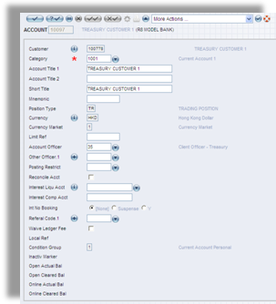  Figure 3. The ACCOUNT screen
 | Facility to enter/change operating conditions/instructions of the account (authorized signatures) and also to view (automatically to pop up) same in the debit transaction screen. | 1 | 5 | Supported by T24.
 | Facility to register the cheque leaves issued to the customer. ie: issued date, No. of cheques, start/end number, utilized/unutilized etc. | 1 | 5 | Supported by T24
 | Facility to debit the customer automatically of service charges based on the type of transaction. i.e. Rs 2 for stamp duty per cheque leaf, monthly service charges based on bank defined criteria (e.g. balance less than a specific amount in a specific account type) | 1 | 5 | Supported by T24.
 | Issue cheque books centrally while the request input to be Front end (Teller level/ Phone/ Internet/ATM)  At the Initial Account Opening to automatically inform the processing unit of the printing | 1 | 5 | System provides tools to interface with front-end system to collect this data.
 | Reorder levels of cheque books to be picked up centrally | 1
 | Facility to enquire the status of a cheque. i.e. paid, stop payment, lost etc. | 1 | 4 | Supported by T24. T24 includes enquiry and reporting tools (T24 Report and Enquiry Designer) to design and produce different types of reports (by fixed period, flexible period, ratios, and particular account head). These utility tools are dynamic and flexible in nature
 | Facility to enter stop payment instructions by individual cheque number or a series of cheque numbers | 1 | 5 | For individual cheque number: T24 supported  For a series of cheque numbers: System provide development toolkit to develop routine to enter multiple check numbers (by batch)
 | Facility to make stop payment of a cheque provided it is not yet debited to the account within last 12 months. | 1 | 5 | Handled by the Stop Payment facility.
 | Facility to debit the account with stop payment charges automatically once the Stop Payment instructions are accepted by the system.  Facility to pop up the stopped cheque message at the inception of the number it self | 1 | 5 | Supported by T24. Handled by the Stop Payment facility.
 | Facility to accept cash (LKR or FCY), cheques, drafts, other credits from workstations or e-banking channels and allow withdrawals by cheque, letter, from workstation or even e-banking channels. | 1 | 5 | Supported by T24 using its Teller or Funds Transfer features.
 | Facility to freely interface with electronically driven banking solutions such as,  ATM  SLIPS (Sri Lanka Interbank Payment System)  SLACH (Sri Lanka Automated Clearing House)  Swift module  Standing orders  E-Windows  Electronic Banking channel  Trade modules  Phone banking  Internet banking  Facility and fee modules  Loans and deposit modules  Cash pooling modules  Treasury modules | 1 | 5 | Temenos Open Connectivity Framework (TOCF) helps to achieve secured & seamless integration with third party systems to receive and react to generate all types of transactions
 | Automatically system to mark accounts unclaimed and dormant after the specified periods. Any transaction to these marked accounts needs the higher level of authorisation (online) and system to automatically route the transaction. This high level authorisation also to be two levels. | 1 | 5 | Supported by T24.
 | Facility to charge respective fees on unclaimed and dormant. | 1 | 5 | Supported by T24.
 | Facility to book and reverse entries with forward and back valuation within allowed maximum value date period (identified at Organizational Level). Any deviation needs a higher level of authorization (online) and system to automatically route the transaction. | 1 | 5 | Supported by T24.
 | Facility to assign dispatch codes at account level and print the customer statements by grouping together. Eg: Retain statements, Staff, Airmail etc., Hold mail | 1 | 5 | Supported by T24. System provide ENQUIRY about account statements and support tools to design and print account statement according to user request
 | Facility to mail statement to more than one address by mail, swift, email or by fax and ability to generate MT940 and MT950 and download to any other application. | 1 | 5 | Supported by T24. System provide DELIVERY module to manage outgoing message in different communication channels, including SWIFT message
 | Facility to define statement frequencies as per below and to print only when there are movement/s during the specified period.  daily when account moves  daily when account moves and a monthly statement  on a specific day of a month  on a specific day of a month and a monthly statement  weekly every defined day  weekly every defined day and a monthly statement  quarterly  yearly  half yearly  defined period  No statement accounts (who will be required to print through internet banking or where the statement could be e-mailed)  Also should be able to define a statement to be printed even if there are NO movements in the account (at customer request, a Nil statement) either daily or monthly.  Facility to automatically charge for such statements above and statements issued on request (issue of duplicate) | 1 | 5 | Supported by T24. System provide ACCOUNT.STATEMENT table to define different criteria and frequencies of account statement printing.  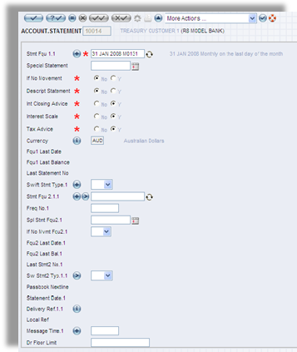  Figure 4. The ACCOUNT.STATEMENT screen
 | Automatic e-mailing of the statement to be allowed. | 1 | 5 | Supported by T24. System provide development toolkit for user to define routine to trigger email generating and integrate with email systems.
 | Facility to mail account balances as at end of day in accounts by SMS, WAP, Fax, email etc | 1 | 5 | Supported by T24. System provide DELIVERY module to manage outgoing message in different communication channels
 | System should always maintain following account balances at any given time.  Book Balance (This is the balance of all debits and credits irrespective of different "dates)  Value Balance (System will take into consideration the "value date" entered in the transaction, in calculating the "Value Balance")  Cleared Balance ("Cleared Balance" is defined as "Book Balance" minus Un-cleared amounts)  Available Balance  Available Balance = Cleared Balance + Unused Limit  OR Available Balance = Cleared Balance - Pledged amount – Blocked amount (if any)  OR Available Balance = Cleared Balance + Unused Limit – Pledged Amount – Blocked Amount | 1 | 5 | Supported by T24.
 | At branch level account to be opened with minimum info. Eg: Customer Name and mandatory fields and provide them with an account number (account pre-open) to facilitate the customer to open the account and deposit initial funds. Unless Central Operations formerly completes the account opening, NO Debits should be allowed to the account (or with higher level of authorization to override the transaction) | 1 | 5 | Supported by T24. System provide parameter table POSTING.RESTRICT to define specific transactions which prohibited for an account.
 | Service charge to be calculated if the minimum balance is not maintained but to check for other available credit balances on other accounts and negate the condition if balance is above the minimum | 1 | 5 | Supported by T24.
 | If the automatic recovery of bank charge (e.g. service fee) is greater than the account balance, the recovery should be only the available balance in the account. In this situation system should automatically issue a letter to customer about the “nil” balance of the account and automatic closure.  Facilitate not to charge minimum balance violation if the account is opened in the middle of the month | 1 | 4 | The automatic recovery of the bank charge is handled by the Past Due module. The module will retry recovery at predefined frequency from the available balance of the account.  The other requirements such as automatic closure upon nil balance of the account and no minimum balance charge will require some local enhancement.
 | Facility to set different minimum balance levels, different charges for personal and business accounts. | 1 | 5 | Supported by T24.  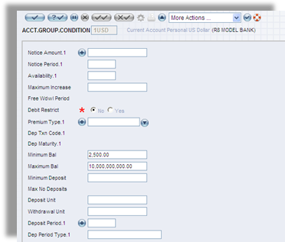  Figure 5. The ACCT.GROUP.CONDITION screen
 | There should be default minimum balance and service charge for each category with account level changes possible. | 1 | 5 | Supported by T24.
 | Account level changes to be included in an exception file with and ability to list all exceptions at any given time. | 1 | 5 | Supported by T24.
 | Controls
 | Account opened should remain inactive until the account opening details are authorized. Facility to have the debit activation key independent of the opening dept. | 1 | 5 | Supported by T24.
 | No debit entries should be permitted if the debit key is inactive. | 1 | 5 | Supported by T24.
 | The activation of the debit key is only allowed at Central Operations once formalizing the account opening. | 1 | 5 | Supported by T24.
 | Facility to restrict authorization of transactions based on limit. | 1 |  | Supported by T24.
 | Facility to separate accounts (types) with special operating conditions. (eg: No debits/credits are allowed or allowed with higher level authorization)  To be able to block the account the same day it is opened | 1 | 5 | Supported by T24. System provide parameter table to define groups of account basing on different criteria
 | Limit number of debits/credits per month and apply service fee or negate interest if exceeds the allowed number. | 1 | 4 | Require adding a local enhancement batch job during month end run.
 | Ability to restrict transactions only through e-Banking, ATM and clearing. Any customer initiated transaction at “Teller” level to charge a service fee automatically. | 1 | 5 | Supported by T24. System provide parameter table to define charge/fee for specific transaction. T24 also provide Open Financial Service (OFS) module to develop connection with other systems like ATM, internet banking, mobile banking
 | Reports
 | Customer advices to include the system generated transactions e.g. Cheque book charges, Stop payment charges,  Dormant charges etc., | 1 | 4 | Supported by T24. T24 includes enquiry and reporting tools (T24 Report and Enquiry Designer) for IT division to design and produce different types of Enquiry/reports (by fixed period, flexible period, ratios, and particular account head). These utility tools are dynamic and flexible in nature
 | Facility to acknowledge the stop payment instructions. Eg: via Swift/SMS/WAP etc.  Facility to check how many times the cheque Number has been returned | 1 | 4 | Supported by T24. T24 includes enquiry and reporting tools (T24 Report and Enquiry Designer) for IT division to design and produce different types of Enquiry/reports (by fixed period, flexible period, ratios, and particular account head). These utility tools are dynamic and flexible in nature
 | Facility to generate a report showing stop payment cheques received via clearing. | 1 | 4 | Supported by T24. T24 includes enquiry and reporting tools (T24 Report and Enquiry Designer) for IT division to design and produce different types of Enquiry/reports (by fixed period, flexible period, ratios, and particular account head). These utility tools are dynamic and flexible in nature
 | Facility to generate reporting of debits and credits to certain accounts with description. | 2 | 4 | Supported by T24. T24 includes enquiry and reporting tools (T24 Report and Enquiry Designer) for IT division to design and produce different types of Enquiry/reports (by fixed period, flexible period, ratios, and particular account head). These utility tools are dynamic and flexible in nature
 | Facility to generate Account Balance Confirmation per Customer (per customer listing all accounts with balances) as at any given date. | 1 | 4 | Supported by T24. T24 includes enquiry and reporting tools (T24 Report and Enquiry Designer) for IT division to design and produce different types of Enquiry/reports (by fixed period, flexible period, ratios, and particular account head). These utility tools are dynamic and flexible in nature
 | Enquiry
 | Facility to check to whom the cheque no belongs to.  Without the account Number | 1 | 5 | Supported by T24. T24 includes enquiry and reporting tools (T24 Report and Enquiry Designer) to design and produce different types of Enquiry/reports (by fixed period, flexible period, ratios, and particular account head). These utility tools are dynamic and flexible in nature. In addition, T24 includes numerous standard predefined enquiries and reports which can be utilized either as templates for designing of enquiries/reports or to be used as enquiries/reports for the Bank.
 | Facility to check the balances either by customer number, customer name, account number, ID or Passport number. | 1 | 5 | Supported by T24. T24 includes enquiry and reporting tools (T24 Report and Enquiry Designer) to design and produce different types of Enquiry/reports (by fixed period, flexible period, ratios, and particular account head). These utility tools are dynamic and flexible in nature. In addition, T24 includes numerous standard predefined enquiries and reports which can be utilized either as templates for designing of enquiries/reports or to be used as enquiries/reports for the Bank.
 | Facility to check the account opening details.  Date of Opening/Who has opened/Closed Date/which branch opened | 1 | 5 | Supported by T24. T24 includes enquiry and reporting tools (T24 Report and Enquiry Designer) to design and produce different types of Enquiry/reports (by fixed period, flexible period, ratios, and particular account head). These utility tools are dynamic and flexible in nature. In addition, T24 includes numerous standard predefined enquiries and reports which can be utilized either as templates for designing of enquiries/reports or to be used as enquiries/reports for the Bank.
 | Facility to check the posting transactions by transaction date, by transaction value, transaction type (eg: Standing Order, Trade etc.,) and transaction reference. | 1 | 5 | Supported by T24. T24 includes enquiry and reporting tools (T24 Report and Enquiry Designer) to design and produce different types of Enquiry/reports (by fixed period, flexible period, ratios, and particular account head). These utility tools are dynamic and flexible in nature. In addition, T24 includes numerous standard predefined enquiries and reports which can be utilized either as templates for designing of enquiries/reports or to be used as enquiries/reports for the Bank.
 | Customer master file information eg: account inform, customer info, limits, fee conditions etc., | 1 | 5 | Supported by T24. T24 includes enquiry and reporting tools (T24 Report and Enquiry Designer) to design and produce different types of Enquiry/reports (by fixed period, flexible period, ratios, and particular account head). These utility tools are dynamic and flexible in nature. In addition, T24 includes numerous standard predefined enquiries and reports which can be utilized either as templates for designing of enquiries/reports or to be used as enquiries/reports for the Bank.
 | All Flex Reports to be available example – Debit Interest Report/manually call for statements/Excess Reports/ Dormant Report |  | 4 | Supported by T24. T24 includes enquiry and reporting tools (T24 Report and Enquiry Designer) to design and produce different types of Enquiry/reports (by fixed period, flexible period, ratios, and particular account head). These utility tools are dynamic and flexible in nature. In addition, T24 includes numerous standard predefined enquiries and reports which can be utilized either as templates for designing of enquiries/reports or to be used as enquiries/reports for the Bank.
 | CHEQUE PURCHASE
 | A Separate Option to Purchase Cheques which would facilitate automatic Crediting and Reversal |  | 5 | Handled by T24 Teller module.
52. | Automatically commission to be charged on the insertion of the amount  SWEEP IN AND SWEEP OUT FACILITY |  | 5 | Handled by T24 Account sweeping or Standing order functionality.
53. | Within all Types of Accounts
54. | Payment of Cheques with overdrawn balances the overrule  To be sent to the relevant RM |  | 5 | Using T24 Process Workflow facility.
55. | Utility Bill Payments |  | 5 | Handled by T24 Data Capture facility.
56. | To hold a separate option to input bill payments with charges being auto routed to the relevant GL |  | 5 | Handled by T24 Data Capture facility.

